SMART CROP ADVISORY SYSTEM
Minor Project Report
Submitted in partial fulfillment of the requirements for the award of the degree of
BACHELOR OF TECHNOLOGY IN
COMPUTER SCIENCE AND ENGINEERING
SUBMITTED BY:
ABHAY MAURYA (221620101001) | AMIT YADAV (221620101010)
VARUN RANA (221620101059) | SHANU AHMED (731620101003)
SAMIR AHMAD (731620101005)
Under the able guidance of
Assistant Prof. Mrs. Sneh Lata Singh


DEPARTMENT OF COMPUTER SCIENCE AND ENGINEERING
DR. A.P.J. ABDUL KALAM INSTITUTE OF TECHNOLOGY TANAKPUR (CHAMPAWAT, UTTARAKHAND) – 262309 (CAMPUS INSTITUTE OF)
VEER MADHO SINGH BHANDARI UTTARAKHAND TECHNICAL UNIVERSITY, DEHRADUN
August– December, 2025

CERTIFICATE
This is to certify that the Minor Project entitled “Smart Crop Advisory System” has been successfully completed and submitted by the following students:
Group Members | Roll No.
Abhay Maurya | 221620101001
Amit Yadav | 221620101010
Varun Rana | 221620101059
Shanu Ahmed | 731620101003
Samir Ahmad | 731620101005
This Minor Project is a record of the students’ original work carried out by them in partial fulfilment of the requirements for the award of the degree of Bachelor of Technology in Computer Science and Engineering from Dr. A.P.J. Abdul Kalam Institute of Technology, Tanakpur (Campus Institute of VMSBUTU, Dehradun), Uttarakhand, India.

Mrs. Sneh Lata Singh | Mr. Naresh Kumar
(Project Mentor) | (Head of Department, CSE)

ACKNOWLEDGEMENT
We would like to express our deepest appreciation to our institute’s director, Prof. Hardwari Lal Mandoria, whose knowledge and astute criticism have been crucial in forming this project and guaranteeing its successful conclusion.
We would like to express our deepest gratitude to our project mentor, Mrs. Sneh Lata Singh, for his valuable guidance, constant encouragement, and insightful suggestions throughout the development of our minor project “Smart Crop Advisory System.” His expertise, patience, and constructive feedback played a crucial role in shaping this project and bringing it to successful completion.
We extend our sincere thanks to Mr. Naresh Kumar, Head of the Department (CSE), for his continuous support, motivation, and for providing us with the facilities and environment necessary for the successful execution of this project.
Finally, we gratefully acknowledge the contributions of Mr. Rishabh Kushawah, Mr. Amit Yadav, Mr. Divisth Jaiswal, Ms. Neha Bisht, Mrs. Komal Gahtori, and Mrs. Shreya Bisht for their academic guidance and constant support during the entire course of this minor project.
We would also like to convey our heartfelt gratitude to our classmates, instructors, and friends for their cooperation, valuable inputs, and encouragement throughout this project. Their moral support and feedback have greatly contributed to the refinement of our work.

Name Roll No. Signature
Abhay Maurya 221620101001 ............................
Amit Yadav 221620101010 ............................
Varun Rana 221620101059 ............................
Shanu Ahmed 731620101003 ............................
Samir Ahmad 731620101005 ............................

LIST OF FIGURES
3.1.1: | System Architecture Diagram for Smart Crop Advisory System (SCAS) | 7
3.1.2: | Workflow Diagram for Smart Crop Advisory System (SCAS) | 7
3.1.3: | ER Diagram for Smart Crop Advisory System (SCAS) | 8
4.2.1 | Illustrates the homepage of the Smart Crop Advisory System. | 14
4.2.2 | Illustrates the crop advisor of the Smart Crop Advisory System. | 14
4.2.3 | Illustrates the fertilizer guide of the Smart Crop Advisory System. | 15
4.2.4 | Illustrates the plant disease detection of the Smart Crop Advisory System. | 15
4.2.5 | Illustrates the services of the Smart Crop Advisory System. | 16
4.2.6 | Illustrates the login page of the Smart Crop Advisory System. | 16
4.2.7 | Illustrates the registration page of the Smart Crop Advisory System. | 17

ABBREVIATIONS
- AI – Artificial Intelligence
- ML – Machine Learning
- SCAS – Smart Crop Advisory System
- CNN – Convolutional Neural Network
- NLP – Natural Language Processing
- API – Application Programming Interface
- NPK – Nitrogen, Phosphorus, Potassium
- IoT – Internet of Things
- CRUD – Create, Read, Update, Delete
- UI – User Interface
- DB – Database
- SQL – Structured Query Language
- JPA – Java Persistence API
- REST – Representational State Transfer
- ERD – Entity Relationship Diagram
- WBS – Work Breakdown Structure

ABSTRACT
Agriculture plays a crucial role in economic growth and food security, particularly in developing countries like India. However, farmers continue to face challenges such as unpredictable weather conditions, soil degradation, improper crop selection, inefficient fertilizer usage, and crop losses due to diseases and weeds. Traditional farming practices largely rely on experience or unverified local advice, which often leads to poor decision-making and reduced agricultural productivity. With the rapid advancement of Artificial Intelligence (AI) and Machine Learning (ML), agriculture is gradually shifting toward data-driven and precision-based practices. The Smart Crop Advisory System (SCAS) is proposed as an intelligent, AI-driven web platform designed to assist farmers in making informed agricultural decisions. The system provides crop recommendations based on soil nutrients and weather conditions, optimized fertilizer suggestions, and early detection of crop diseases and weeds using deep learning techniques. Real-time weather alerts are integrated to help mitigate climate-related risks. Additionally, a community and blog module enables knowledge sharing among farmers. By integrating multiple advisory services into a unified platform, SCAS aims to enhance crop productivity, reduce losses, optimize resource usage, and promote sustainable farming practices through technology-driven solutions

TABLE OF CONTENT

ACKNOWLEDGEMENT i
LIST OF FIGURES ii
ABBREVIATIONS iii
ABSTRACT iv
Chapter 1. INTRODUCTION 1
1.1 Problem Statement 1
1.2 Objectives 2
Chapter 2. LITERATURE REVIEW 3
2.1 Summary of Existing Solutions 4
2.2 Identification of Research Gaps 5
Chapter 3. TECHNOLOGY AND METHODOLOGY 6
3.1 System Architecture 6
3.1.1 Technology Stack 6
3.1.2 AI & ML Components 6
3.1.3 Notification System 6
3.1.4 Blog Page Implementation 6
3.2 Methodology 8
3.3 Software Requirements 9
3.4 Hardware Requirements 10
3.5 Work Breakdown Structure (WBS) 11
3.4 Gantt Chart 12
Chapter 4. RESULTS AND DISCUSSION 13
3.1 Expected Outcome 13
4.2 Final Outcome 13
4.3 Future Scope 17
Chapter 5. CONCLUSIONS 18
Chapter 6. REFERENCES 19
APPENDIX-A 20
File Structure of Project 20
APPENDIX – B 23
ABSTRACT IN HINDI 23
APPENDIX – C 24
VITAE 24
VITAE 25
VITAE 26
VITAE 27
VITAE 28

Chapter 1

INTRODUCTION
Agriculture is the backbone of many economies, yet farmers continue to face challenges such as unpredictable weather, soil degradation, improper crop selection, and crop losses due to diseases and weeds. Traditional farming practices often rely on experience rather than data-driven insights, which increases production risks and reduces yield efficiency. With the advancement of Artificial Intelligence (AI) and Machine Learning (ML), modern agriculture is shifting toward precision-based decision making. The Smart Crop Advisory System (SCAS) is designed to assist farmers by providing intelligent recommendations for crop selection, fertilizer usage, and early detection of diseases and weeds. By analyzing soil nutrients, weather conditions, and crop images, the system delivers accurate, real-time advisories. SCAS aims to enhance productivity, minimize losses, and promote sustainable farming through technology-driven solutions.

1.1 Problem Statement
A majority of India’s small and marginal farmers still depend on guesswork or unverified local advice from shopkeepers when making critical agricultural decisions regarding crop selection, fertilizer usage, and pest control.
This leads to:
- Ineffective farming practices,
- Excessive use of fertilizers and pesticides,
- Declining soil health, and
- Reduced agricultural productivity and income.
Without reliable data or expert guidance, farmers remain trapped in a cycle of low yields, high input costs, and environmental degradation.

1.2 Objectives
The main objectives of the proposed project are:
- To develop an AI‑based crop recommendation system using soil and weather parameters.
- To design a fertilizer recommendation module for optimal fertilizer recommendation.
- To detect crop diseases and weeds using image‑based deep learning models.
- To provide real-time weather alerts for risk mitigation.
- To enable farmers to make informed, data-driven, and sustainable farming decisions through a collaborative community platform.

Chapter 2

LITERATURE REVIEW
Recent advancements in Artificial Intelligence (AI) and Machine Learning (ML) have fundamentally reshaped modern agriculture, transitioning the sector from traditional intuition-based practices to precise, data-driven decision-making frameworks. As global challenges like climate volatility and soil degradation intensify, these technologies have become essential for optimizing resource use and securing yields. A significant portion of current research has focused on Crop Recommendation Systems, which utilize algorithms to analyze critical soil parameters—such as Nitrogen, Phosphorus, Potassium, and pH—alongside climatic variables like temperature, humidity, and rainfall. Among various ML techniques, Random Forest has emerged as a superior method for this application, consistently achieving high accuracy due to its robust ability to interpret the complex, non-linear relationships inherent in agricultural data. Parallel to this, Fertilizer Recommendation Systems have evolved to leverage supervised learning models that process specific soil test data to prescribe exact nutrient dosages. This precision is vital not only for maximizing crop productivity but also for preventing the environmental damage caused by chemical overuse, thus preserving long-term soil health. In the realm of plant pathology, Crop Disease Detection has been revolutionized by Deep Learning, specifically Convolutional Neural Networks (CNNs). These visual models demonstrate exceptional proficiency in identifying plant diseases from leaf imagery, enabling early diagnosis and timely intervention that can save entire harvests. However, despite the individual success of these technologies, the current Ag-Tech landscape remains heavily fragmented. Most existing solutions operate in isolation, addressing only one aspect of farming—be it crop selection, nutrient management, or disease control—forcing farmers to navigate multiple disjointed tools. There is a scarcity of research focused on integrating these diverse functionalities into a single, unified platform. Furthermore, the practical challenges of deploying these sophisticated systems in real-world scenarios, particularly regarding scalability and accessibility for rural farmers with limited digital literacy, remain significantly under-addressed. Consequently, the next frontier in smart farming lies not just in refining these algorithms, but in consolidating them into a holistic, user-friendly ecosystem that makes high-level agricultural intelligence accessible to the grassroots farming community.

2.1 Summary of Existing Solutions
- Most existing systems focus on single-function solutions, such as crop recommendation, fertilizer advisory, or disease detection independently.
- Machine learning models like Random Forest are widely used for crop and fertilizer recommendation due to their high accuracy on structured data.
- Deep learning models, especially CNNs, are commonly employed for crop disease detection using leaf images.
- Several solutions demonstrate high accuracy in controlled environments but lack real-world deployment readiness.
- Deployment strategies often rely on monolithic architectures, limiting scalability and flexibility.
- User accessibility is frequently overlooked, especially for farmers with low-end devices or poor internet connectivity.

2.2 Identification of Research Gaps
Despite significant advancements, the literature reveals several critical research gaps:
- Lack of Integrated Systems: Existing studies address crop recommendation, fertilizer optimization, and disease detection separately, with very few systems integrating all these components into a unified advisory platform.
- Limited Real-World Deployment: High accuracy results are often achieved using controlled datasets, which may not generalize well to diverse agro-climatic regions and real-field conditions.
- Scalability and Architecture Issues: Many solutions do not leverage cloud-native microservices, leading to poor scalability and difficulty in managing multiple AI models simultaneously.
- Poor Accessibility for Rural Farmers: Limited focus on offline functionality, low-bandwidth usage, and mobile-friendly platforms restrict adoption among small and marginal farmers.
- Lack of Continuous Feedback and Community Support: Most systems do not include mechanisms for farmer feedback, community interaction, or collaborative knowledge sharing.

Chapter 3

TECHNOLOGY AND METHODOLOGY

3.1 System Architecture
The Smart Crop Advisory System will be developed as a Java Spring Boot web application using microservices architecture for modularity and scalability.

3.1.1 Technology Stack
- Backend: Spring Boot, Spring Data JPA, Spring Security
- Frontend: HTML, CSS, JavaScript, AJAX
- Database: MySQL (for cloud storage and remote access)

AI & ML Components
- Crop Recommendation Model: Trained using historical soil and yield data with Machine Learning algorithms.
- Fertilizer Optimization: Regression and classification-based models for precise dosage calculation.
- Plant Disease Detection: Implemented using Deep Learning (CNN) for analyzing uploaded crop images.
- Multilingual Chatbot: NLP-based AI chatbot integrated with translation APIs and text-to-speech tools for voice support.

3.1.3 Notification System
- WhatsApp Alerts: Spring Boot backend triggers automated alerts for disease outbreaks and severe weather events.

3.1.4 Blog Page Implementation
- Developed using Spring Boot, JavaScript, and MySQL database.
- Supports CRUD operations and real-time updates using AJAX.
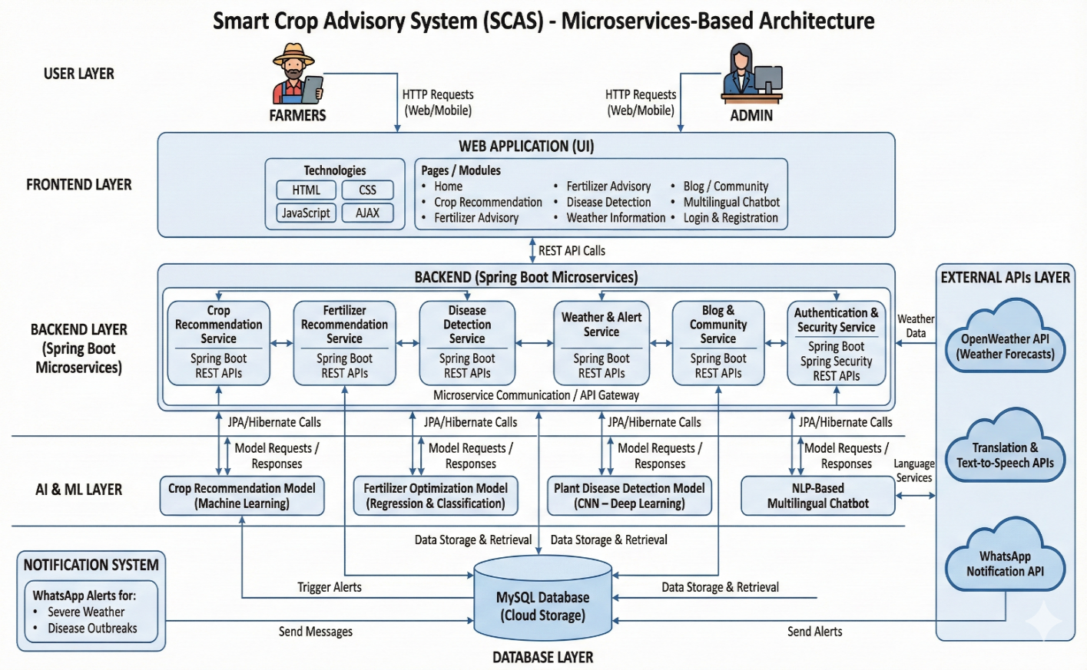
Figure 3.1.1: System Architecture Diagram for Smart Crop Advisory System (SCAS).

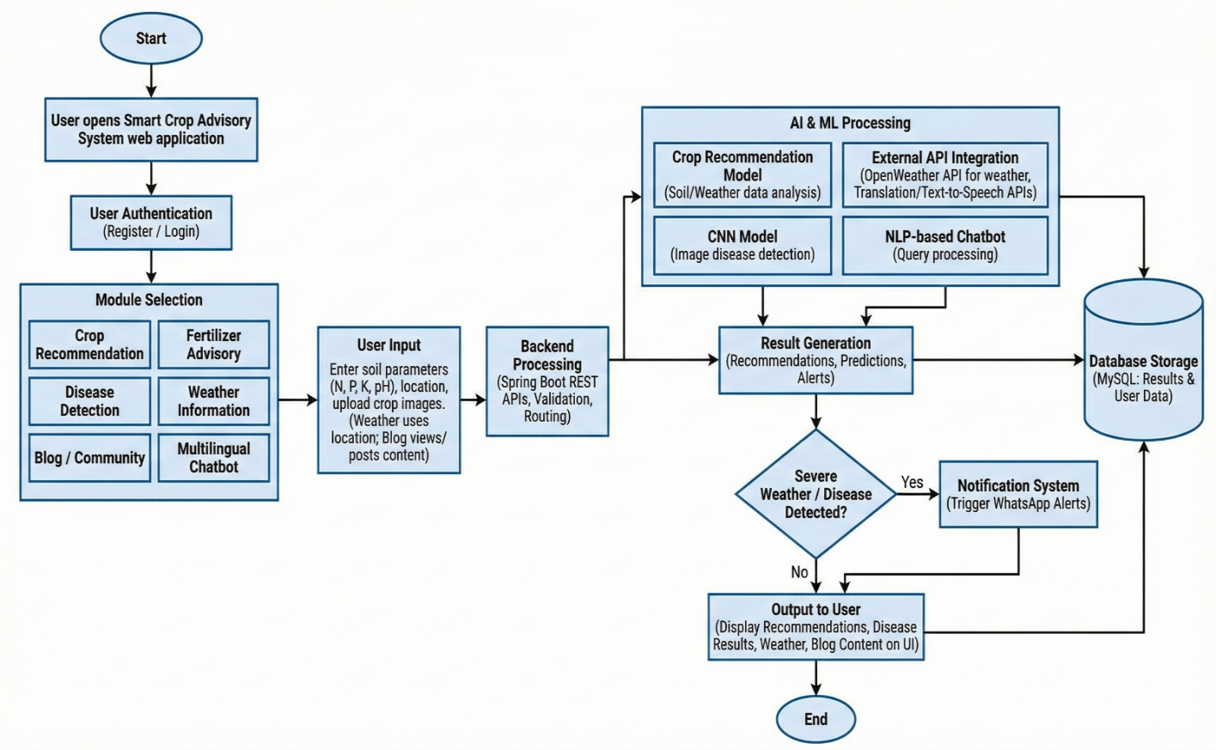
Figure 3.1.2: Workflow Diagram for Smart Crop Advisory System (SCAS).
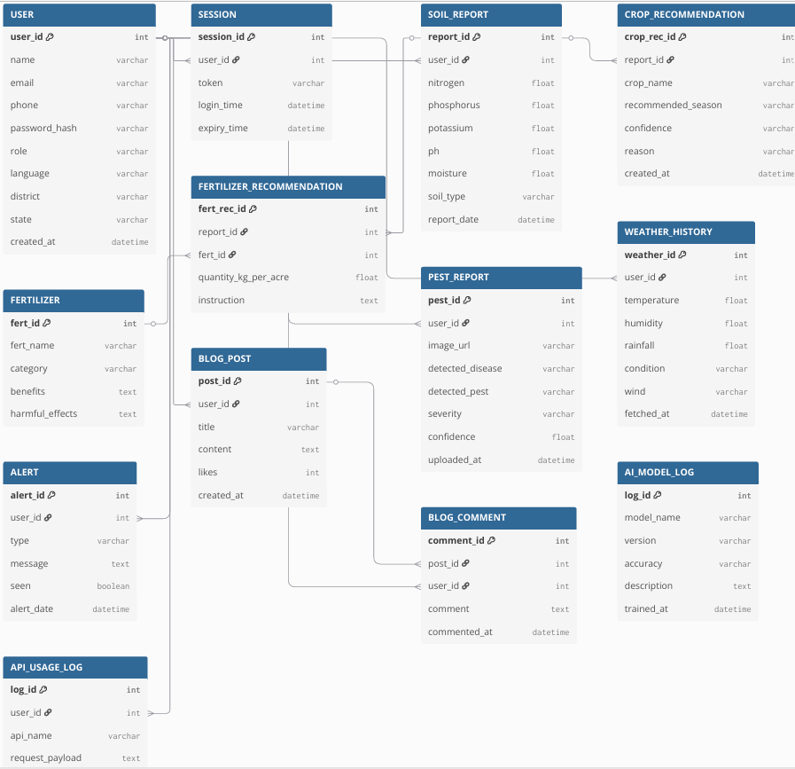
Figure 3.1.3: ER Diagram for Smart Crop Advisory System (SCAS).

3.2 Methodology
The methodology of the Smart Crop Advisory System (SCAS) is designed to provide intelligent, data-driven agricultural recommendations by integrating machine learning, deep learning, and web-based technologies. The process begins with the collection of agricultural datasets related to soil nutrients, crop types, fertilizer information, weather conditions, and disease images from reliable open-source platforms. The collected data is cleaned, normalized, and preprocessed to handle missing values and inconsistencies. 6 Machine learning algorithms are then trained using historical soil and weather data to develop an accurate crop recommendation model. Based on soil nutrient levels and selected crops, fertilizer recommendation models are implemented using classification and regression techniques to suggest optimal fertilizer types and usage. For crop protection, a deep learning-based Convolutional Neural Network (CNN) is used to detect diseases and weeds from uploaded crop images. Real-time weather data is integrated through the OpenWeather API to generate alerts for adverse climatic conditions. All components are integrated using a Spring Boot microservices architecture, ensuring modularity and scalability. The system uses MySQL for online data storage and SQLite for offline support, delivering a reliable, user-friendly, and scalable agricultural advisory platform.

Software Requirements
The Smart Crop Advisory System (SCAS) is developed using modern web technologies, machine learning frameworks, and database systems to ensure scalability, accuracy, and user accessibility. The required software components are listed below:
- Operating System: Windows 10 / 11, Linux (Ubuntu), or macOS
- Programming Languages: Java (for backend development), Python (for Machine Learning and Deep Learning models)
- Backend Framework: Spring Boot, Spring Data JPA, Spring Security
- Frontend Technologies: HTML, CSS, JavaScript, AJAX
- Machine Learning & Deep Learning Libraries: Python, NumPy, Pandas, Scikit-learn, TensorFlow, Keras
- Database Management System: MySQL
- APIs & Tools: OpenWeather API (for weather data), RESTful APIs, WhatsApp API (for alert notifications)
- Development Tools: Eclipse (for Java), Jupyter Notebook (for Python), Postman (API testing), Git (version control)

Hardware Requirements
The hardware requirements for the Smart Crop Advisory System are modest and suitable for development, testing, and deployment on standard computing systems.
- Processor: Intel Core i5 or higher (or equivalent AMD processor)
- RAM: Minimum 8 GB (16 GB recommended for ML/DL training)
- Storage: Minimum 256 GB HDD/SSD (SSD preferred for faster performance)
- Graphics Processing Unit (Optional): NVIDIA GPU with CUDA support (recommended for deep learning model training)
- Network: Stable Internet connection for API access, dataset download, and cloud services
- User Devices: Desktop / Laptop / Smartphone with web browser (for accessing the system)

3.5 Work Breakdown Structure (WBS)
Table 1: Work Breakdown Structure
S.No. | Phase | Task | Description
1 | Planning | Problem study & requirement analysis | Identify key functional and non- functional requirements
2 | Design | System architecture, database, and UI design | Create ERD, UML, and UI mockups
3 | Development (Backend) | Spring Boot microservices | Implement modules for chatbot, alerts, and data analytics
4 | Development (Frontend) | Responsive web UI | Build HTML/CSS/JS interface with localization support
5 | AI Model Development | Data preprocessing, model training | Train ML models for  crop/fertilizer/disease prediction
6 | Integration | Connect backend, AI models, and APIs | Integrate OpenWeather, database, and chatbot
7 | Testing | Unit, integration, and user testing | Validate accuracy, reliability, and usability
8 | Documentation & Report | Final report, user manual | Prepare project report and demo documentation

3.4 Gantt Chart
Table 2: Gantt Chart
Week | Tasks | Details / Deliverables
Week 1 | Requirement Analysis & System Design | Finalize project scope, prepare system architecture diagrams, and collect datasets related to soil, crops, fertilizers, and pests.
Week 2 | Backend & Frontend Development | Develop Spring Boot backend services, configure MySQL database, and build a responsive frontend using HTML, CSS, and JavaScript.
Week 3 | AI Integration & API Connectivity | Implement machine learning models for crop prediction and fertilizer recommendation, integrate CNN for disease detection, and connect OpenWeather API and chatbot services.
Week 4 | Testing, Optimization & Deployment | Perform functional and user testing, fix bugs, integrate WhatsApp alert system, deploy the application, and prepare final documentation.

Chapter 4

RESULTS AND DISCUSSION

Expected Outcome
- The system is expected to provide accurate crop recommendations based on soil nutrients, weather conditions, helping farmers select suitable crops for improved yield.
- The fertilizer recommendation module will enable optimized fertilizer usage, reducing over-application, improving soil health, and lowering input costs.
- The disease and weed detection module is expected to support identification of crop threats using image-based deep learning models, thereby minimizing crop loss.
- Integration of real-time weather data will help generate timely weather alerts, allowing farmers to take preventive actions against adverse climatic conditions.
- The system is anticipated to mitigate up to 60% of avoidable agricultural risks related to crop failure, nutrient mismanagement, and disease outbreaks.
- Overall, SCAS will promote data-driven and sustainable farming practices, enhance productivity, and provide farmers with a reliable, user-friendly decision-support platform.

4.2 Final Outcome
The final outcome of the Smart Crop Advisory System (SCAS) is a fully integrated, AI-driven web platform that provides intelligent agricultural decision support to farmers. The system successfully combines crop recommendation, fertilizer advisory, disease and weed detection, and real-time weather alerts into a single, user-friendly application. By leveraging machine learning and deep learning techniques, SCAS delivers accurate and personalized recommendations based on soil parameters, environmental conditions, and crop images. The implementation of a Spring Boot microservices architecture ensures scalability, modularity, and efficient system performance. Additionally, the inclusion of a community and blog module promotes knowledge sharing and collaborative decision-making among farmers. Overall, the system demonstrates the practical application of Artificial Intelligence in agriculture, enabling farmers to reduce risks, optimize resources, improve crop productivity, and adopt sustainable farming practices through data-driven insights.
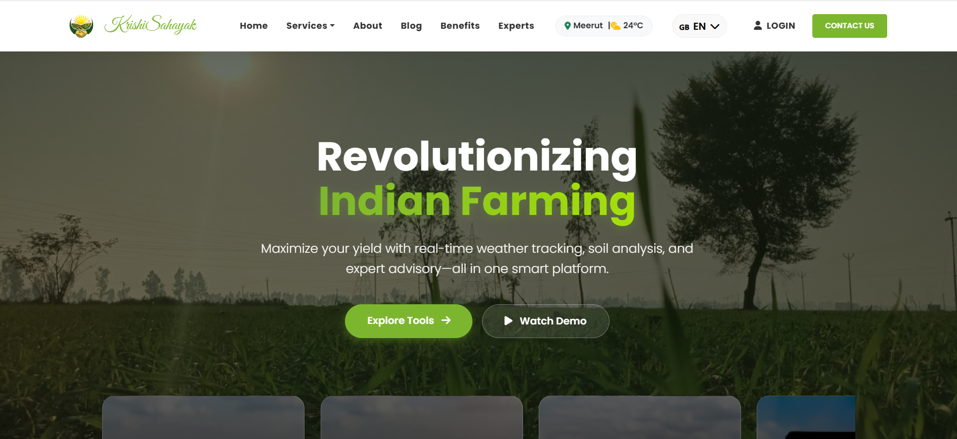
Figure 4.2.1 illustrates the homepage of the Smart Crop Advisory System.
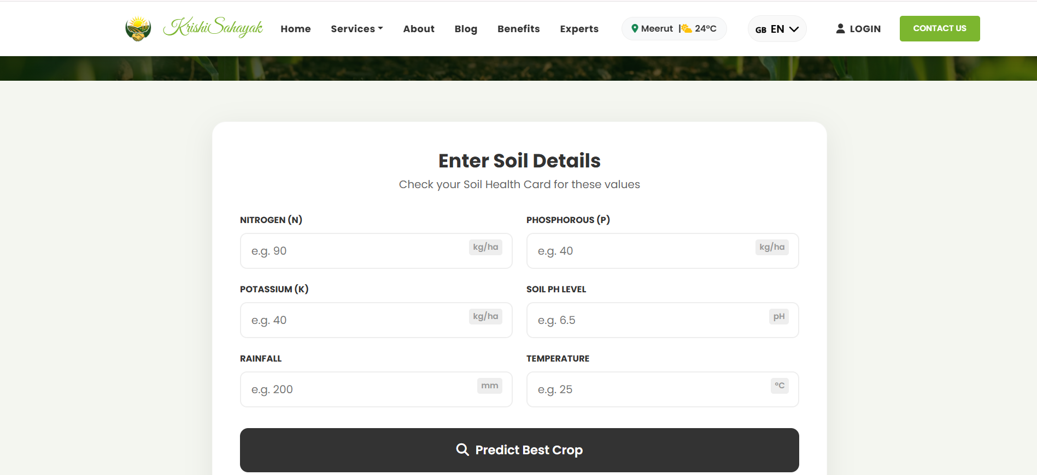
Figure 4.2.2 illustrates the crop advisor of the Smart Crop Advisory System.
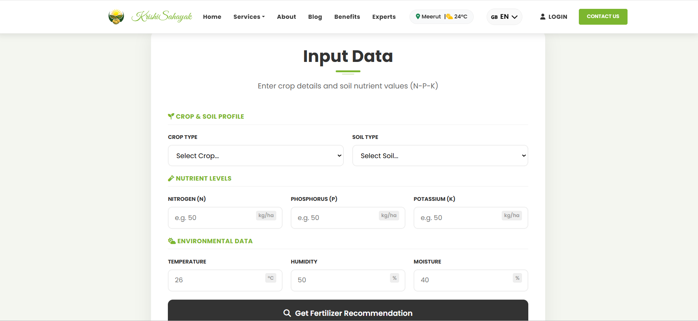
Figure 4.2.3 illustrates the fertilizer guide of the Smart Crop Advisory System.
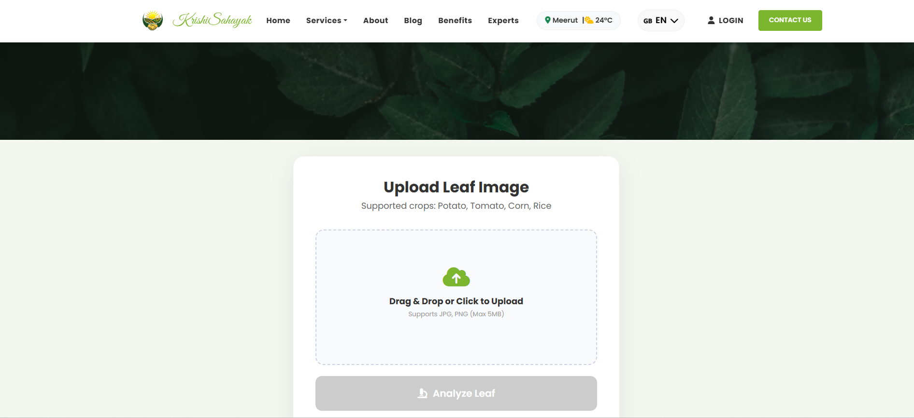
Figure 4.2.4 illustrates the plant disease detection of the Smart Crop Advisory System.
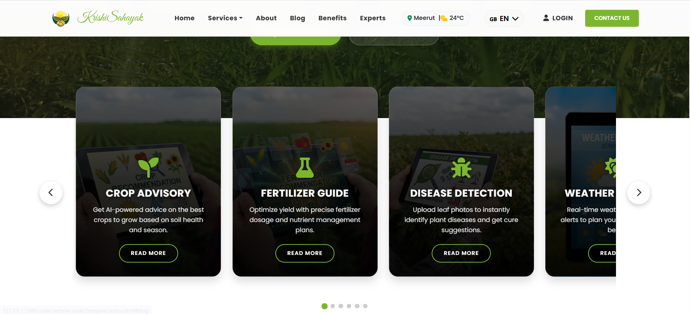
Figure 4.2.5 illustrates the services of the Smart Crop Advisory System.
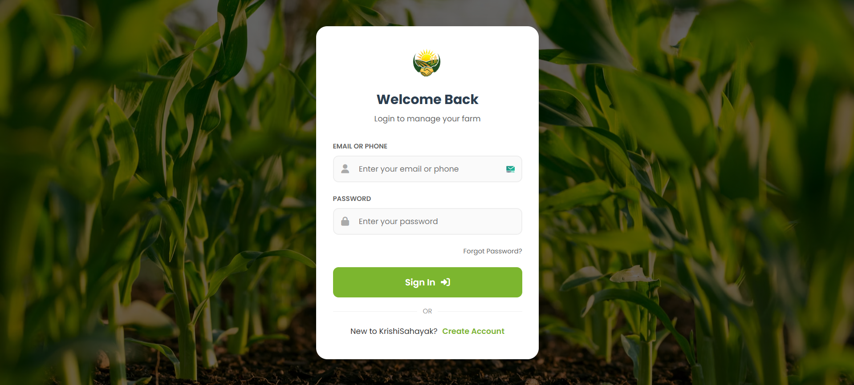
Figure 4.2.6 illustrates the login page of the Smart Crop Advisory System.
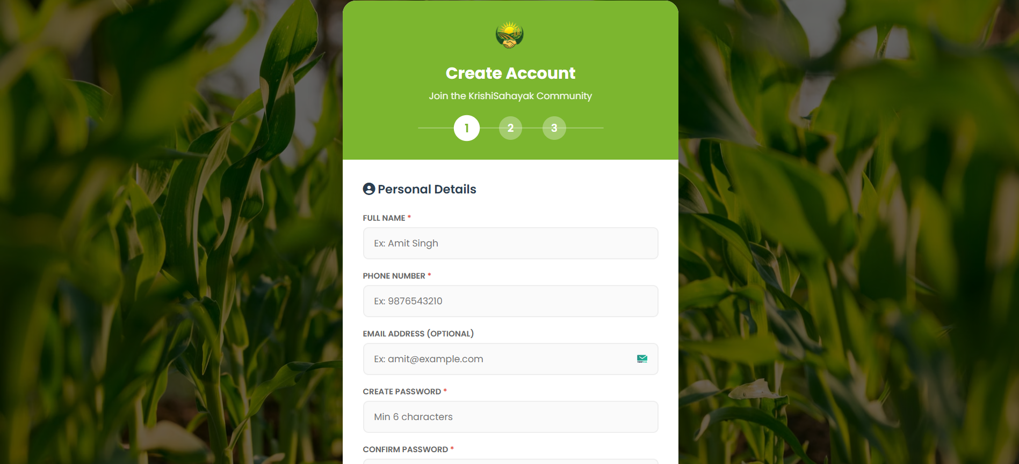
Figure 4.2.7 illustrates the registration page of the Smart Crop Advisory System.

4.3 Future Scope
- Multilingual and Voice-Based Support: The system can be enhanced with multilingual and voice-enabled advisory features to make it accessible to farmers from different linguistic backgrounds.
- IoT-Based Soil Monitoring: Integration of IoT sensors can enable real-time monitoring of soil moisture, nutrient levels, and environmental conditions for more accurate recommendations.
- Mobile Application Development: A dedicated mobile application can be developed to improve accessibility and provide on-the-go advisory services to farmers.
- Market Price Prediction and Supply Chain Integration: Future versions may include market price forecasting and supply chain integration to help farmers make informed decisions regarding crop sales and distribution.

Chapter 5

CONCLUSIONS
The Smart Crop Advisory System (SCAS) stands as a definitive testament to the transformative potential of integrating Artificial Intelligence (AI) and Machine Learning (ML) within the agricultural sector, successfully demonstrating how advanced computational models can be harnessed to resolve the multifaceted challenges of modern farming. By synthesizing diverse functionalities—including intelligent crop recommendation, precise fertilizer optimization, automated disease and weed detection, and real-time weather monitoring—into a single, unified platform, SCAS effectively eliminates the technological fragmentation that has historically hindered the widespread adoption of digital tools among smallholder farmers. This holistic integration empowers users to transition from traditional, intuition-based methods to a robust framework of data-driven decision-making, where every choice regarding seed selection or nutrient management is backed by scientific analysis rather than guesswork. The system’s reliance on sophisticated Machine Learning algorithms, such as Random Forest for processing complex soil-climate interactions and Convolutional Neural Networks (CNNs) for visual diagnostics, ensures that farmers receive expert-level advice that was previously inaccessible to resource-constrained communities. Beyond merely enhancing immediate productivity, SCAS actively promotes long-term agricultural sustainability; by prescribing precise fertilizer dosages and enabling early threat detection, it minimizes the reliance on blanket chemical applications, thereby preserving soil health and reducing environmental contamination. Ultimately, SCAS serves as a scalable model for the future of food production, proving that when cutting-edge technology is made accessible and user-friendly, it can significantly reduce agricultural risks, stabilize farm incomes, and accelerate the global shift from subsistence farming to high-efficiency precision agriculture.

REFERENCES
- Chaudhary, A., Gupta, M., & Tiwari, U. (2023). Crop disease detection using deep learning models. In Proceedings of the 2023 IEEE International Conference on Recent Advances in Systems Science and Engineering (RASSE). IEEE.
- Ingole, A. A., & Karale, N. E. (2025). Java in microservices architecture: A study on Spring Boot and cloud-native development. International Journal of Ingenious Research, Invention and Development, 4(2).
- Kaggle. (2024). Agricultural datasets for crop, fertilizer, and disease prediction. https://www.kaggle.com
- Mamatha, G., & Nayak, J. S. (2024). A novel design and implementation of fertilizer recommendation system based on hybrid machine learning models. SSRG International Journal of Electrical and Electronics Engineering, 11(11), 448–460.
https://doi.org/10.14445/23488379/IJEEE-V11111P141
- Murad, A. (2025, August 19–20). Comparative performance and user experience: PWAs vs. native mobile applications. In Proceedings of the 11th International Scientific and Practical Conference “Current Issues and Prospects for the Development of Scientific Research” (pp. 246–260). InterConf.
https://doi.org/10.51582/interconf.19-20.08.2025.027
- National Bank for Agriculture and Rural Development. (2022). Annual report. NABARD.
- Pawan, Yadav, D., Sharma, R. K., Kumar, M., Rani, J., & Sharma, N. (2024). An effective approach for crop recommendation using features of specific locations and seasons to maximize crop yield production using machine learning. International Journal of Intelligent Systems and Applications in Engineering, 12(18s), 844–850.

APPENDIX-A

File Structure of Project
Smart_Crop_Advisory_System/
│
├── 📄 README.md # Project documentation
├── 📄 .gitignore # Ignores compiled files, venv, target/
├── 📄 LICENSE # Open Source License (e.g., MIT)
│
├── 📂 backend/ # [BODY] Java Spring Boot Core
│ ├── 📄 mvnw, mvnw.cmd # Maven Wrappers
│ ├── 📄 pom.xml # Dependencies (Spring Web, JPA, Security, MySQL)
│ │
│ └── 📂 src/
│ ├── 📂 main/
│ │ ├── 📂 java/com/scas/
│ │ │ ├── 📄 ScasApplication.java # Main Entry Point
│ │ │ │
│ │ │ ├── 📂 config/ # Configuration Layer
│ │ │ │ ├── 📄 SecurityConfig.java # Auth rules
│ │ │ │ ├── 📄 CorsConfig.java # Allow frontend requests
│ │ │ │ └── 📄 RestClientConfig.java # Config to talk to Python APIs
│ │ │ │
│ │ │ ├── 📂 controller/ # API Layer (REST Controllers)
│ │ │ │ ├── 📄 AuthController.java
│ │ │ │ ├── 📄 BlogController.java
│ │ │ │ ├── 📄 CropController.java
│ │ │ │ ├── 📄 DiseaseController.java
│ │ │ │ ├── 📄 FertilizerController.java
│ │ │ │ └── 📄 WeatherController.java
│ │ │ │
│ │ │ ├── 📂 service/ # Logic Layer
│ │ │ │ ├── 📄 AuthService.java
│ │ │ │ ├── 📄 BlogService.java
│ │ │ │ ├── 📄 CropService.java
│ │ │ │ ├── 📄 DiseaseService.java
│ │ │ │ ├── 📄 FertilizerService.java
│ │ │ │ ├── 📄 WeatherService.java
│ │ │ │ └── 📄 MlGatewayService.java # Bridges Java to Python
│ │ │ │
│ │ │ ├── 📂 model/ # Database Entities
│ │ │ │ ├── 📄 User.java
│ │ │ │ ├── 📄 Role.java
│ │ │ │ ├── 📄 FarmLog.java
│ │ │ │ └── 📄 BlogPost.java
│ │ │ │
│ │ │ ├── 📂 repository/ # Data Access Object (DAO)
│ │ │ │ ├── 📄 UserRepository.java
│ │ │ │ ├── 📄 FarmLogRepository.java
│ │ │ │ └── 📄 BlogRepository.java
│ │ │ │
│ │ │ ├── 📂 dto/ # Data Transfer Objects
│ │ │ │ ├── 📄 LoginRequest.java
│ │ │ │ ├── 📄 SignupRequest.java
│ │ │ │ └── 📄 PredictionResponse.java
│ │ │ │
│ │ │ └── 📂 exception/ # Error Handling
│ │ │ └── 📄 GlobalExceptionHandler.java
│ │ │
│ │ └── 📂 resources/
│ │ ├── 📄 application.yml # DB Creds & Port Config
│ │ └── 📄 logback-spring.xml # Logging Config
│ │
│ └── 📂 test/
│ └── 📂 java/com/scas/
│ └── 📄 ScasApplicationTests.java
│
├── 📂 ml_services/ # [BRAIN] Python AI Microservices
│ ├── 📂 models/ # Trained Model Files
│ │ ├── 📄 crop_recommendation.pkl
│ │ ├── 📄 fertilizer_model.pkl
│ │ ├── 📄 final_disease_model.h5
│ │ ├── 📄 class_indices.json
│ │ ├── 📄 scaler.pkl
│ │ └── 📄 label_encoder.pkl
│ │
│ ├── 📂 notebooks/ # Research & Training
│ │ ├── 📄 1_Crop_EDA_Training.ipynb
│ │ ├── 📄 2_Fertilizer_EDA.ipynb
│ │ └── 📄 3_Disease_MobileNetV2.ipynb
│ │
│ ├── 📄 crop_api.py # FastAPI Service (Port 8000)
│ ├── 📄 fertilizer_api.py # FastAPI Service (Port 8001)
│ ├── 📄 disease_api.py # FastAPI Service (Port 8002)
│ └── 📄 requirements.txt # Python dependencies
│
├── 📂 frontend/ # [FACE] User Interface
│ ├── 📂 assets/
│ │ ├── 📂 img/ # Logos, Backgrounds
│ │ └── 📂 icons/
│ ├── 📂 css/ # Custom Styles
│ │ └── 📄 style.css
│ ├── 📂 js/ # Frontend Logic
│ │ └── 📄 main.js
│ │
│ ├── 📄 index.html # Landing Page
│ ├── 📄 login.html # Auth Page
│ ├── 📄 register.html # Signup Page
│ ├── 📄 dashboard.html # User Home
│ ├── 📄 crop.html # Crop Tool
│ ├── 📄 fertilizer.html # Fertilizer Tool
│ ├── 📄 disease.html # Disease Detection Tool
│ ├── 📄 weather.html # Weather Advisory Tool
│ └── 📄 blog.html # Community Page
│
├── 📂 data/ # Raw Datasets
│ ├── 📄 Crop_recommendation.csv
│ ├── 📄 Fertilizer_prediction.csv
│ └── 📂 Plant_Disease_Dataset/
│
└── 📂 docs/ # Diagrams & Reports
├── 📄 system_architecture.png
├── 📄 er_diagram.png
├── 📄 flow_chart.png
└── 📄 project_report.pdf

APPENDIX – B

ABSTRACT IN HINDI
कृषि आर्थिक विकास और खाद्य सुरक्षा में महत्वपूर्ण भूमिका निभाती है, विशेष रूप से भारत जैसे विकासशील देशों में। हालांकि, किसानों को आज भी अनिश्चित मौसम परिस्थितियों, मिट्टी की उर्वरता में कमी, गलत फसल चयन, उर्वरकों के अनुचित उपयोग तथा रोगों और खरपतवारों के कारण फसल नुकसान जैसी कई चुनौतियों का सामना करना पड़ता है। पारंपरिक कृषि पद्धतियाँ मुख्य रूप से अनुभव या अप्रमाणित स्थानीय सलाह पर निर्भर होती हैं, जिसके कारण अक्सर गलत निर्णय लिए जाते हैं और कृषि उत्पादकता में कमी आती है।
कृत्रिम बुद्धिमत्ता (AI) और मशीन लर्निंग (ML) में हो रही तीव्र प्रगति के साथ कृषि क्षेत्र धीरे-धीरे डेटा-आधारित और सटीक निर्णय-निर्माण की ओर बढ़ रहा है। स्मार्ट क्रॉप एडवाइजरी सिस्टम (SCAS) एक बुद्धिमान, AI-आधारित वेब प्लेटफॉर्म के रूप में प्रस्तावित है, जिसका उद्देश्य किसानों को सूचित कृषि निर्णय लेने में सहायता करना है। यह प्रणाली मिट्टी के पोषक तत्वों और मौसम की स्थिति के आधार पर फसल अनुशंसा, उर्वरकों के लिए अनुकूल सुझाव तथा डीप लर्निंग तकनीकों के माध्यम से फसल रोगों और खरपतवारों की प्रारंभिक पहचान प्रदान करती है। जलवायु-संबंधी जोखिमों को कम करने के लिए रियल-टाइम मौसम अलर्ट भी एकीकृत किए गए हैं। इसके अतिरिक्त, समुदाय और ब्लॉग मॉड्यूल किसानों के बीच ज्ञान साझा करने में सहायक हैं। विभिन्न परामर्श सेवाओं को एकीकृत मंच पर जोड़कर, SCAS का उद्देश्य फसल उत्पादकता बढ़ाना, नुकसान कम करना, संसाधनों के उपयोग को अनुकूल बनाना और तकनीक-आधारित समाधानों के माध्यम से सतत कृषि पद्धतियों को बढ़ावा देना है।

APPENDIX – C

VITAE

The author Abhay Maurya was born on 31/03/2004 at Rudrapur. He passed his high school during the year 2020 and his Intermediate in 2022 from “Himalayan Progressive School, Kichha”
He joined as an under graduate student in Dr. APJ. Abdul Kalam Institute of Technology, Tanakpur, Champawat for program Bachelor of Technology (Computer Science & Engineering).

Address For Communication
––––––––––––––––––––––
Abhay Maurya
S/O Mr. Umesh Kumar Maurya
Kichha Pin code -263148
+91 8191826630
abhay.maurya0303@gmail.com

VITAE

The author, Amit Yadav was born on 29/03/2004 at Rudrapur. He passed his high school during the year 2020 and his Intermediate in 2022 from “Jaycees public School”.
He joined as an under graduate student in Dr. APJ. Abdul Kalam Institute of Technology, Tanakpur, Champawat for program Bachelor of Technology (Computer Science & Engineering).

Address For Communication
–––––––––––––––––––––––
Amit Yadav
S/O Mr. Ram Pravesh Yadav
Kichha Pin code -263153
+917439327622
Amity3289@gmail.com

VITAE

The author, Shanu Ahmed was born on 5/12/2005 at Almora. He passed his Diploma during the year 2023 from “Government Polytechnic Kanda Bageshwar”.
He joined as an under graduate student in Dr. APJ. Abdul Kalam Institute of Technology, Tanakpur, Champawat for program Bachelor of Technology (Computer Science & Engineering).

Address For Communication
––––––––––––––––––––––
Shanu Ahmed
S/O Mr. Shamshad Ahmed
Almora Pin code - 263601
+91 7055417849
shanuahmed03@gmail.com

VITAE

The author, Varun Rana was born on 22/04/2004 at Sitarganj. He passed his high school during the year 2019 and his Intermediate in 2021 from “P.P.S.V.M. Intercollege, Nanakmatta”.
He joined as an under graduate student in Dr. APJ. Abdul Kalam Institute of Technology, Tanakpur, Champawat for program Bachelor of Technology (Computer Science & Engineering).

Address For Communication
––––––––––––––––––––––
Varun Rana
S/O Mr. Ashok Singh Rana
Sitarganj, Pin code - 262405
+91 7500961740
varunrana1902@gmail.com

VITAE

The author, Sameer Ahmad was born on 10/07/2003 at Khatima. He passed his Diploma during the year 2023 from “Government Polytechnic, SakhtiFarm”.
He joined as an under graduate student in Dr. APJ. Abdul Kalam Institute of Technology, Tanakpur, Champawat for program Bachelor of Technology (Computer Science & Engineering).

Address For Communication
––––––––––––––––––––––
Samir Ahmad
S/O Mr. Naseem Ahmed
Khatima Pin code -262308
+91 8077705884
azharahmad5310@gmail.com

